FSR and Applications

20220827 Fang Wenqu

Piezoresistive effect: resistance changes with the pressure on it

Analog to digital conversion (ADC): convert analog signals to digital readings

Achieved by analogRead(pinNumber).

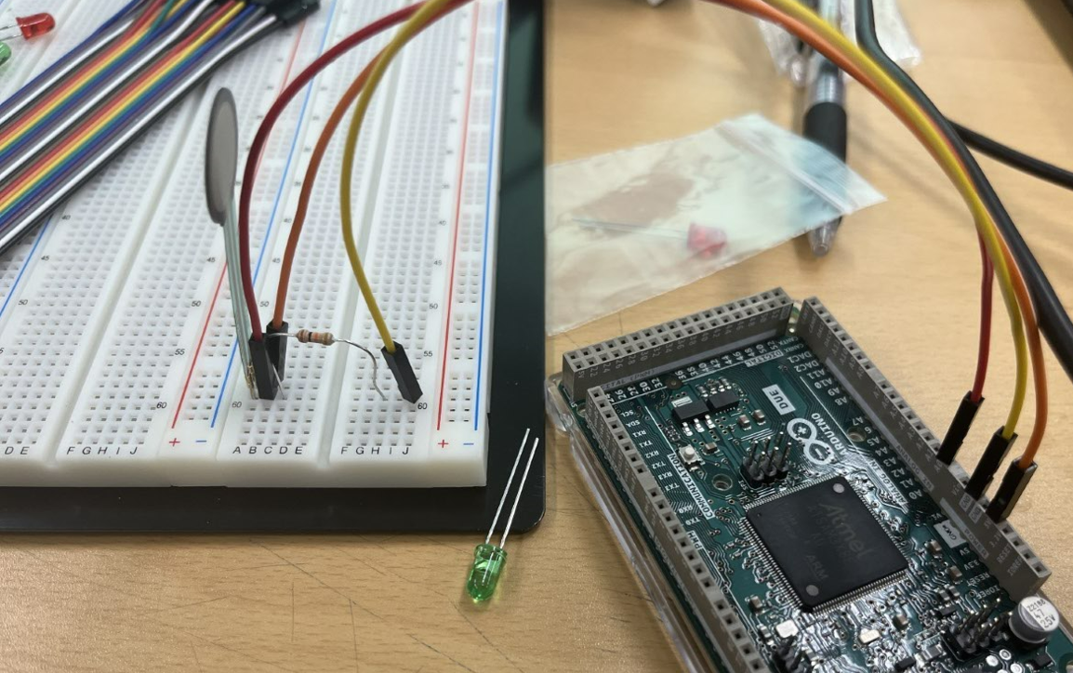

Figure FSR Basic

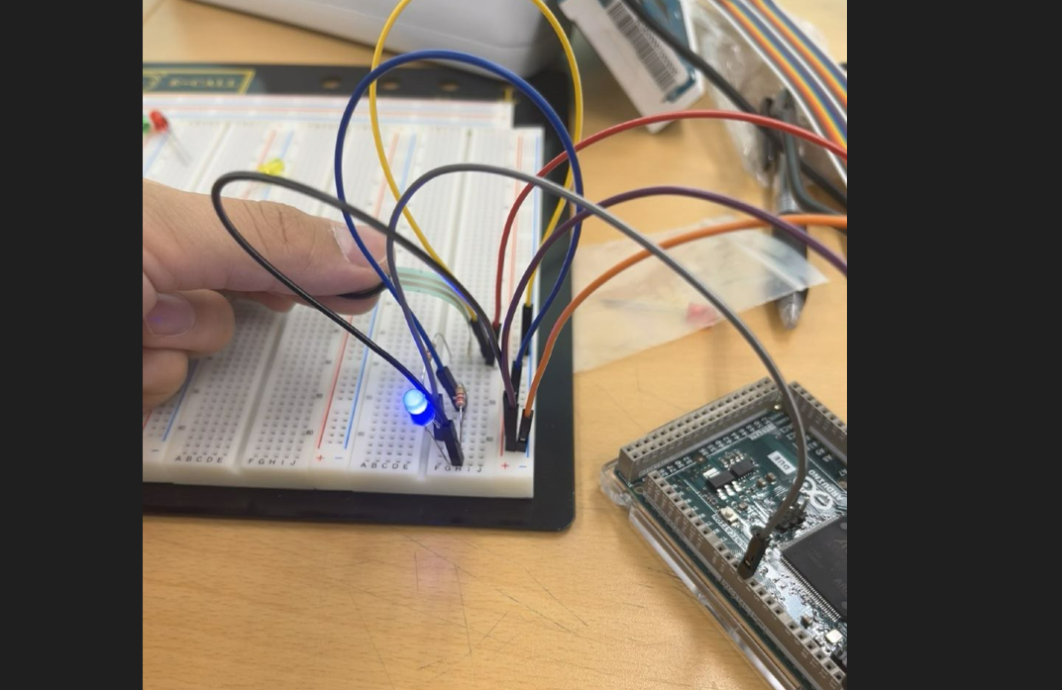

Figure FSR and LED 1

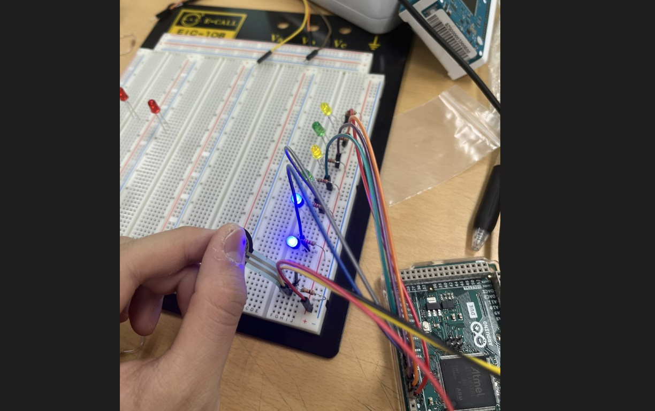

Figure FSR and LED 2